Project Planning Phase
Project Planning Template (Product Backlog, Sprint Planning, Stories, Story points)

Date | 29 June 2026
Team ID
Project Name | ONLINE COMPLAINT REGISTRATION
Maximum Marks | 5 Marks

Product Backlog, Sprint Schedule, and Estimation (4 Marks)
Use the below template to create product backlog and sprint schedule
Sprint | Functional Requirement (Epic) | User Story Number | User Story / Task | Story Points | Priority | Team Members
Sprint-1 | Registration & Login | USN-1 | As a user, I can register for the application by entering my name, email, password, and confirming my password. | 3 | High | Lakshmi Prasanna
Sprint-1 |  | USN-2 | As a user, my password is securely hashed (bcrypt) before being stored in the database. | 2 | High | Lakshmi Prasanna
Sprint-1 |  | USN-3 | As a user, I can log in with my email and password and receive a JWT for authenticated access. | 3 | High | Lakshmi Prasanna
Sprint-1 |  | USN-4 | As a user/agent/admin, I am redirected to my role-specific dashboard and blocked from routes outside my role. | 3 | High | Lakshmi Prasanna
Sprint-1 | Project Setup | USN-5 | As a developer, I can scaffold the backend (Express) and frontend (React + Vite) project structure. | 3 | High | Lakshmi Prasanna
Sprint-1 |  | USN-6 | As a developer, I can connect the backend to MongoDB and define Mongoose models (User, Complaint, Agent, Feedback, Message). | 3 | High | Lakshmi Prasanna
Sprint-1 | Dashboard | USN-7 | As a user, I see a navigation bar and am routed to the correct dashboard based on my role. | 3 | Medium | Lakshmi Prasanna
Sprint-2 | Complaint Management | USN-8 | As a user, I can submit a new complaint with title, description, category, and priority. | 3 | High | Lakshmi Prasanna
Sprint-2 |  | USN-9 | As a user, I can view a list of all complaints I have submitted along with their current status. | 2 | High | Lakshmi Prasanna
Sprint-2 |  | USN-10 | As a user, I can open a complaint to view its full details. | 2 | Medium | Lakshmi Prasanna
Sprint-2 |  | USN-11 | As an admin, I can view all complaints submitted across the system. | 3 | High | Lakshmi Prasanna
Sprint-2 |  | USN-12 | As an admin, I can assign an agent to a submitted complaint. | 3 | High | Lakshmi Prasanna
Sprint-2 |  | USN-13 | As an agent, I can view only the complaints that have been assigned to me. | 3 | High | Lakshmi Prasanna
Sprint-2 |  | USN-14 | As an agent, I can update the status of a complaint (Assigned -> In Progress -> Resolved -> Closed). | 2 | High | Lakshmi Prasanna
Sprint-2 |  | USN-15 | As a developer, I can define the complaint status lifecycle as an enum/state machine. | 2 | Medium | Lakshmi Prasanna
Sprint-3 | Real-time Chat | USN-16 | As a developer, I can set up a Socket.io server authenticated with the same JWT used for REST calls. | 3 | High | Lakshmi Prasanna
Sprint-3 |  | USN-17 | As a user, I can chat in real time with the agent assigned to my complaint. | 4 | High | Lakshmi Prasanna
Sprint-3 |  | USN-18 | As an agent, I can chat in real time with the user who submitted the complaint. | 2 | High | Lakshmi Prasanna
Sprint-3 | Feedback | USN-19 | As a user, I can submit a rating (1-5) and comment once my complaint is resolved. | 3 | High | Lakshmi Prasanna
Sprint-3 |  | USN-20 | As an admin, I can view the average customer satisfaction rating across all resolved complaints. | 2 | Medium | Lakshmi Prasanna
Sprint-3 | Notifications | USN-21 | As a user, I receive an email notification when my complaint is assigned/resolved (Nodemailer). | 3 | Low | Lakshmi Prasanna
Sprint-3 | Stabilization | USN-22 | As a developer, I can resolve missing-dependency and server-crash issues found during integration testing. | 3 | High | Lakshmi Prasanna
Sprint-4 | Admin Analytics | USN-23 | As an admin, I can view a dashboard showing status distribution and complaints-by-category charts. | 4 | High | Lakshmi Prasanna
Sprint-4 |  | USN-24 | As an admin, I can view recent complaints and overall system activity at a glance. | 2 | Medium | Lakshmi Prasanna
Sprint-4 | UI/UX Polish | USN-25 | As a user, I experience a polished, professional dashboard UI consistent across all roles. | 4 | Medium | Lakshmi Prasanna
Sprint-4 | Security Hardening | USN-26 | As a developer, I secure the app with Helmet, strong seed credentials, and remove demo data from the UI. | 3 | High | Lakshmi Prasanna
Sprint-4 | Testing | USN-27 | As a tester, I execute UAT test cases covering all major user flows and log/fix any bugs found. | 4 | High | Lakshmi Prasanna
Sprint-4 | Release | USN-28 | As a developer, I finalize documentation and push the completed project to GitHub. | 3 | Medium | Lakshmi Prasanna

Project Tracker, Velocity & Burndown Chart: (4 Marks)
Sprint | Total Story Points | Duration | Sprint Start Date | Sprint End Date (Planned) | Story Points Completed (as on Planned End Date) | Sprint Release Date (Actual)
Sprint-1 | 20 | 6 Days | 01 June 2026 | 06 June 2026 | 20 | 06 June 2026
Sprint-2 | 20 | 6 Days | 08 June 2026 | 13 June 2026 | 20 | 13 June 2026
Sprint-3 | 20 | 6 Days | 15 June 2026 | 20 June 2026 | 20 | 20 June 2026
Sprint-4 | 20 | 6 Days | 22 June 2026 | 27 June 2026 | 20 | 27 June 2026

Velocity:
Imagine we have a 10-day sprint duration, and the velocity of the team is 20 (points per sprint). Let’s calculate the team’s average velocity (AV) per iteration unit (story points per day)
AV = Total Story Points / Sprint Duration = 20 points / 10 days = 2 story points per day.
Applied to this project: each of our 4 sprints delivered 20 story points over a 6-day duration, giving an actual average velocity of 20 / 6 ≈ 3.33 story points per day. Across all 4 sprints, the team delivered a total of 80 story points over 24 working days.

Burndown Chart:

A burn down chart is a graphical representation of work left to do versus time. It is often used in agile software development methodologies such as Scrum. However, burn down charts can be applied to any project containing measurable progress over time.

https://www.visual-paradigm.com/scrum/scrum-burndown-chart/
https://www.atlassian.com/agile/tutorials/burndown-charts

Reference:
https://www.atlassian.com/agile/project-management
https://www.atlassian.com/agile/tutorials/how-to-do-scrum-with-jira-software
https://www.atlassian.com/agile/tutorials/epics
https://www.atlassian.com/agile/tutorials/sprints
https://www.atlassian.com/agile/project-management/estimation
https://www.atlassian.com/agile/tutorials/burndown-charts

Actual Burndown Chart - Sprint-4 (ResolveHub / Online Complaint Registration)
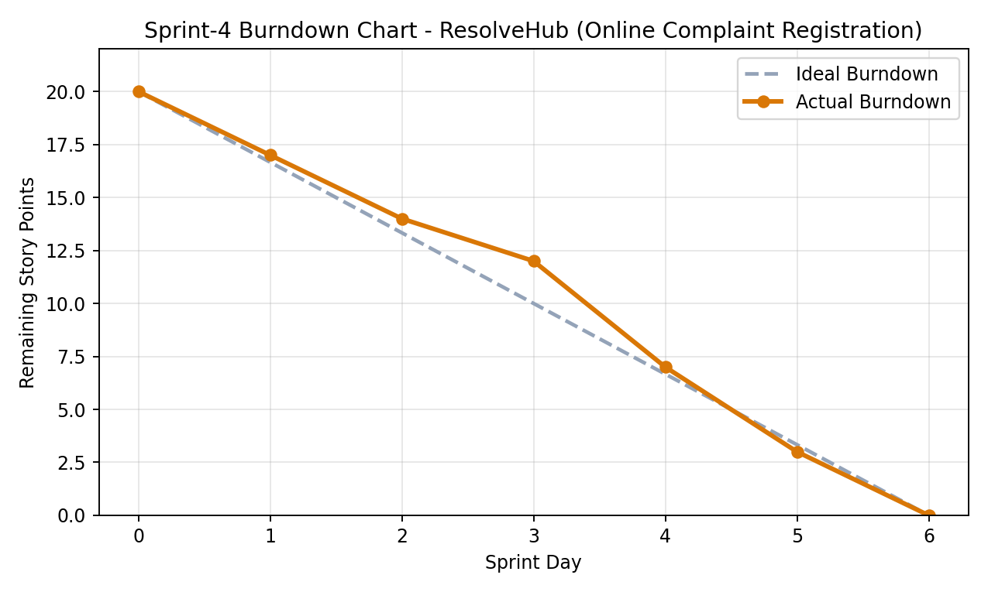
The chart above tracks Sprint-4 (22 June 2026 - 27 June 2026), where the team planned to burn down 20 story points over 6 days. Actual progress closely tracked the ideal line, with a short dip in days 3-4 (debugging the missing-dependency and security-hardening tasks) that the team caught up on by Day 5, completing the sprint exactly on schedule.

